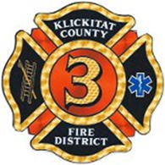
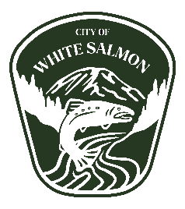
Special Meeting of
Klickitat County Fire District 3 Commissioners
And City of White Salmon

 | West Klickitat Regional Fire Authority Planning Committee
Date | July 24, 2023
Time | 18:00 (6pm)
Location | 119 NE Church, White Salmon WA 98672
Join Zoom Meeting | https://us02web.zoom.us/j/81846701701
Meeting ID | 818 4670 1701
Pass Code | No Password
Call in Numbers | 669-900-6833 929-205-6099 301-715-8592  346-248-7799 253-215-8782 312-626-6799

Agenda
- Open Meeting: KCFD3 meeting to be run in tandem with White Salmon City Council
- Call to order.
City of White Salmon Council
KCFD3 Commissioners
Attendance/Roll call

- Changes to the Agenda /Approval of the Agenda

- Public Comment

- Business Items

Resolution 2023-10 – Joint resolution with City of White Salmon authorizing WKRFA to go on the November Ballot.
- Review- WKRFA Final Plan is available under supporting documents.
- Discussion
- Action:

- Adjournment
- Motion to adjourn:

